Grantham Kids Aquathlon 2018

A round of the BTF East Midlands Youth Series

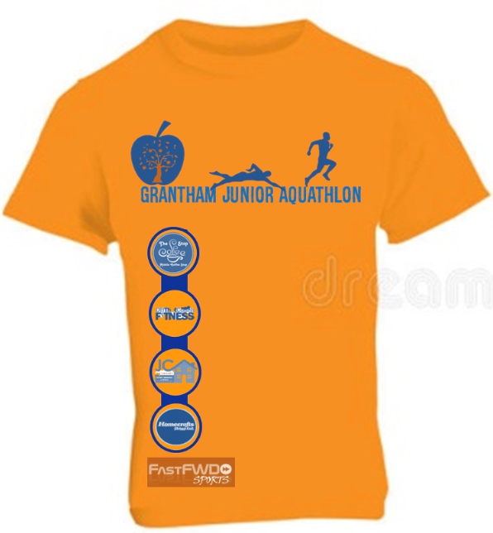

Sunday 13th May 2018
Grantham Kids Aquathlon 2018
Race Information Pack
PLEASE TAKE THE TIME TO READ
Event Details

Venue:
Meres Leisure Centre
Trent Road
Grantham
NG31 7XQ
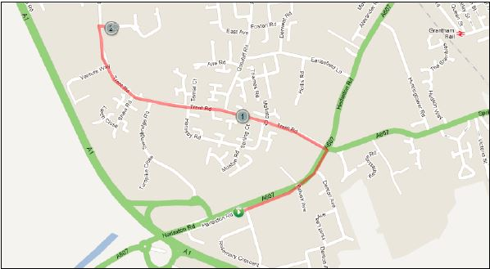
Race Start Time:
Wave 1 (Youth) off at 07:30am

Race Registration:
Saturday 10th May 5.00pm – 7.00 pm (near Transition Area)
Sunday 11th May 6:00am – 7:30am (near Transition Area)

Race Briefing:
0700am (Transition Area) All competitors to attend.

Safety
The first and most important consideration is the safety of all competitors and volunteers.
We have completed Risk Assessments and do our best to highlight any hazards etc.
You as a competitor have a Duty of Care to yourself and others. You must also be sure of your abilities and fitness to compete in, and complete the race disciplines. You MUST have regard for other competitors and officials, all of whom give their time for your pleasure and pain! Please take time to carefully study the pre-race information to ensure you have a smooth and enjoyable day out. The race starts at 7:30am and will be on set off in waves of EIGHT at 2 minute intervals. Individual start times will be emailed prior to the race and also on display on the day at registration.

Parents
Experience has shown that some parents can have a tendency to get over-excited while their
child is racing. Parents please remember that the child will be guided by the race marshals as to
where they should proceed depending on the stage of the race they are at. Remember that this is
intended to be fun, encourage participation and enjoyment for the children, and for the parents.

Parents behaviour can and does influence the performance of children, and if negative has the potential to put the kids off racing. We encourage positive cheering and support for ALL participants.

Unacceptable behaviour by parents will not be tolerated whether that is towards other children that are racing or to race marshals who give up their time to enable this and other races to take place.

No Olympic medals will be handed out today!

Grantham Kids Aquathlon 2018 race Distances

Category | Age (on 31st Dec 2018) | Swim metres | Run
Youth | 15/16 | 400m | 3.6k
TS3 | 13-14 | 400m | 2.4k
TS2 | 11-12 | 250m | 1.2k
TS1 | 9-10 | 150m | 1.2k

Registration
Race registration will be open on Saturday & Sunday (times stated above) and is located close to transition (see map).
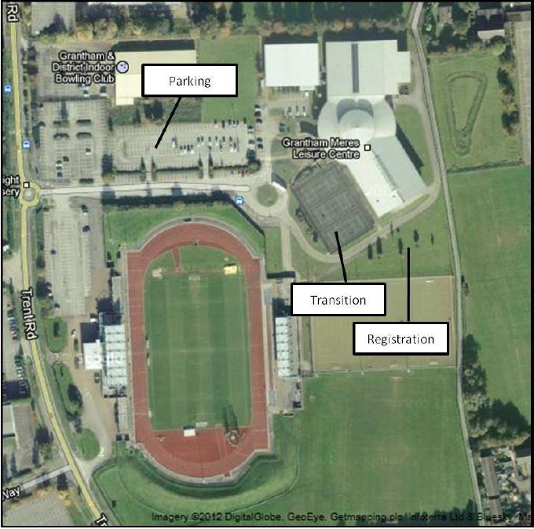

Timing
You will be issued with a single race numbers for your front of your race top, if you are wearing a race belt the number must be visible on your front for the run section. You will receive a timing chip to place on your LEFT ankle at the poolside . To ensure the security of the timing chip it is advised that you secure the Velcro strap with the safety pin(s) provided.

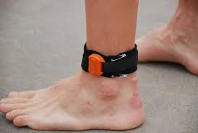

Race Registration:
Please follow the directions given by volunteers to find Registration. You must register or you will not be able to participate in the event.

East Midlands Series /TE License
If you have entered as a TE / Home Nations member you will be required to show your Race License. We need to check the number on your license matches the number you have given us at the point of
Entry – this is so that East Midlands Series points can be allocated accurately after the event.
If you are unable to show your license you will be required to purchase a day license at a cost of £1. This process may well result in registration taking longer than normal.
We recommend that you give yourself additional time for this! DO NOT arrive at the last minute and expect to blitz through registration quickly.
Competitors or parents will not be entitled to register on behalf of another competitor. Please
ensure that before registering on the day you know your race number. This can be found by downloading a list of competitors from the race website or by checking the start lists as you
enter registration.

Transition Area (opens at 6.00 am)
Only Competitors allowed in the transition area! NO PARENTS!

Changing Facilities
Changing areas and showers are available within the Leisure Centre.

Swim (150m/250m/400m)
The event will start at 07:30am please enter the swim area via the normal pool entrance in the Leisure Centre at least 10 minutes prior to your start time. The pool is 8 lanes & 25 metres in length, start times will be staggered (dependant on your estimated swim time) at 2 minute intervals. Please ensure you check in with the pool marshall 10 minutes before your start time (start times will be published in the week before the event). You will be asked to enter the water 30 seconds before your start time & given a countdown, you will swim 6/10 or 16 lengths as per your race distance.
Please remember it is your responsibility to count your lengths, marshals will be conducting spot checks, anyone found not completing the correct number of lengths will either be disqualified or subject to a time penalty.
On completion of your swim you must exit the pool via the doors indicated, please DO NOT run while still on the edge of the pool as this is slippery. Once outside the leisure centre follow the route out of the doors and into transition.
Please remember that you will not be in a lane by yourself, if a faster swimmer taps your toes please let them through at the end of the next length. Faster swimmers may also over take down the middle of the lane but please take care of oncoming swimmers.
All start times and lane numbers will be advised approximately 1 week prior to race day via email.

Run (1.2km per lap)
Exit the transition area through the OUT gate, and through the opened fence, turning right onto the pathway (the green arrow on the map).
Proceed to the end of the pathway turning right as you rejoin Trent Road and continue along Trent Road towards the Leisure Centre. As you approach the Leisure Centre entrance turn right following the marked route on pathway to the finish line near transition.
For additional laps athletes will run alongside the finish area next to the fence line where marshalls will issue a lap band.
Athletes will collect 1 band per lap. When athletes have completed the required number of laps they will enter the finish chute and cross the finish line.
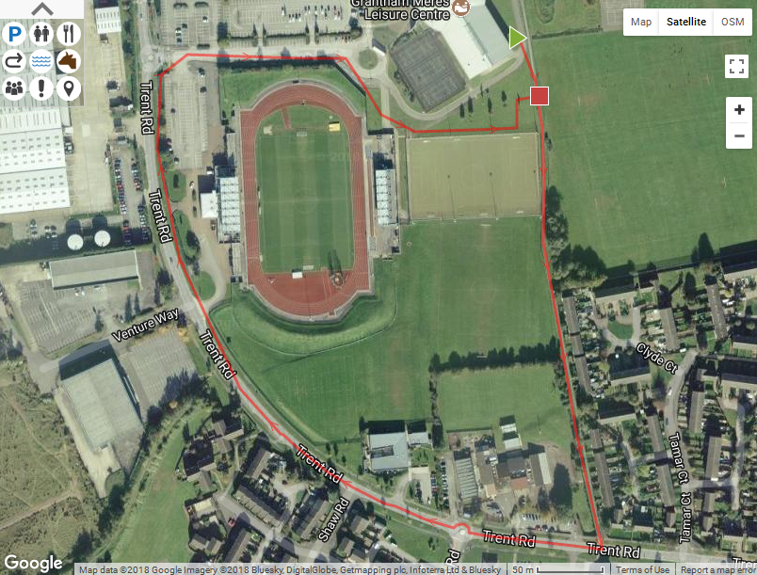

Prizes and presentation

Presentation will be held at the registration area shortly after the final competitor has finished. (Estimated 08:45am).
There will be awards for 1st, 2nd & 3rd in male & female categories.

Results
Results will be available online the same evening of the event at www.FastFWDSports.co.uk

Contact
If you have any issues before race day please email Info@FastFWDSports.co.uk, and on race day please see the Race Director David Hinch or Senior Marshalls Steve Clark and Andy Veitch.

Please have safe and enjoyable race and help us to make this a regular event on the triathlon calendar.
Please show respect for all marshals as they are volunteers and without them it would not be possible for the event to take place, a simple thank you post race goes a long way.

We hope you have a good day and wish you every success no matter what your goal.

Team FastFWDSports

